- Enable cloudtrail monitoring and store the events in s3 and cloudwatch log events.

1. Task Title**

Enable AWS CloudTrail Monitoring and Store Events in S3 and CloudWatch Logs

2. Objective**

To configure AWS CloudTrail to capture API activity across the account and securely store the logs in an S3 bucket while also streaming events to CloudWatch Logs for monitoring and alerting.

3. Prerequisites**

* AWS account with IAM permissions to create CloudTrail, S3 bucket, and CloudWatch Log Group
(e.g., `cloudtrail:CreateTrail`, `s3:CreateBucket`, `logs:CreateLogGroup`, etc.)
* Region selected where CloudTrail will be configured

4. Step-by-Step Implementation**

### Step 1: Create a CloudTrail Trail**

1. Go to **CloudTrail Console**
2. Click **Create trail**
3. Enter a Trail Name (e.g., `OrganizationTrail` or `MyAccountTrail`)
4. **Storage location: **

* Choose the create new S3 bucket
Or
* Choose use existing s3 bucket as per requirement

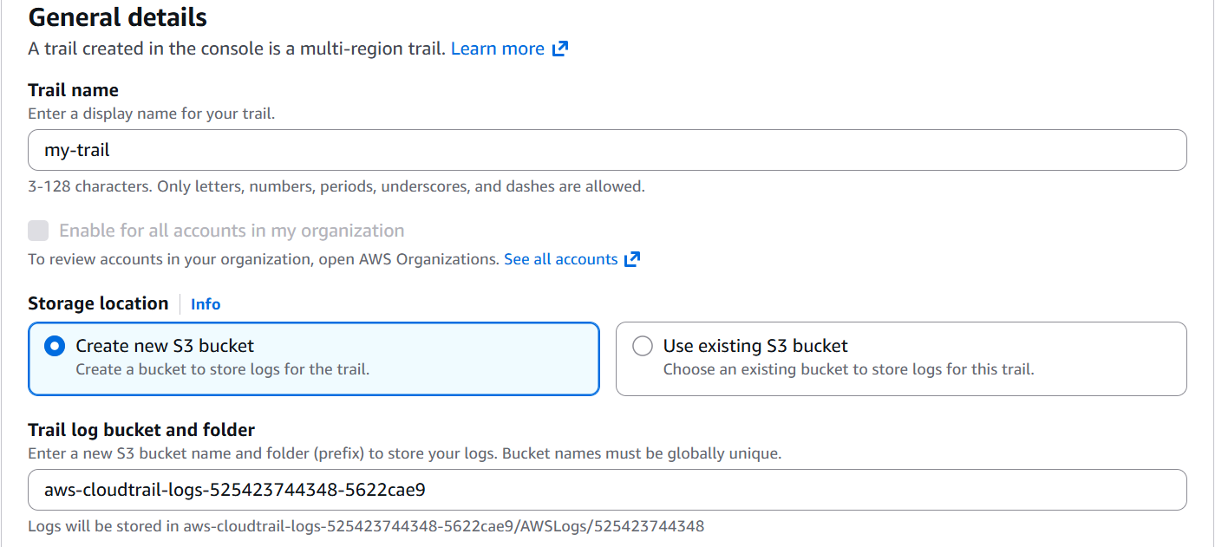

5. **CloudWatch Logs:**

* Enable **CloudWatch Logs**
* Choose the new or existing Log Group as per requirement
* Allow CloudTrail to create the required IAM role

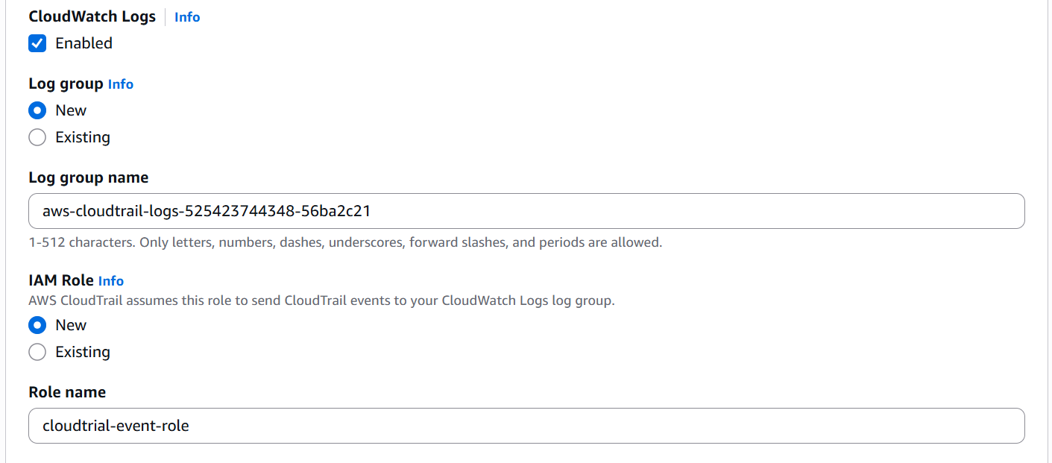
6. Select:

* **Apply trail to all regions**
* **Management events → Read/Write**

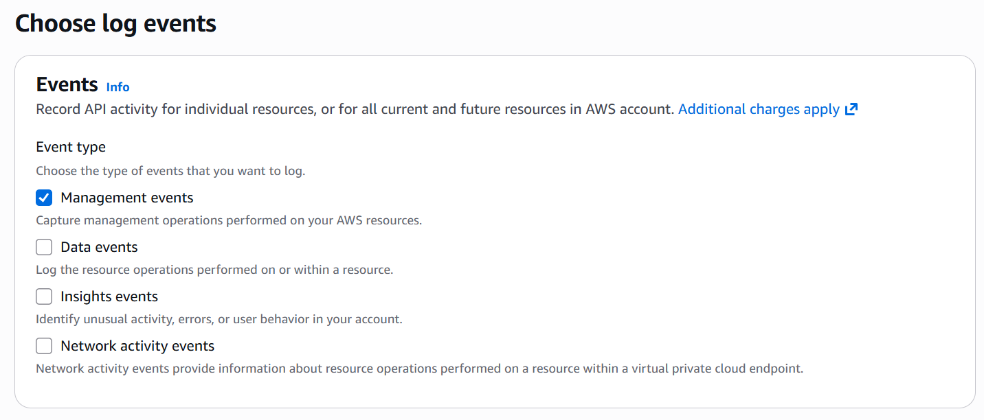
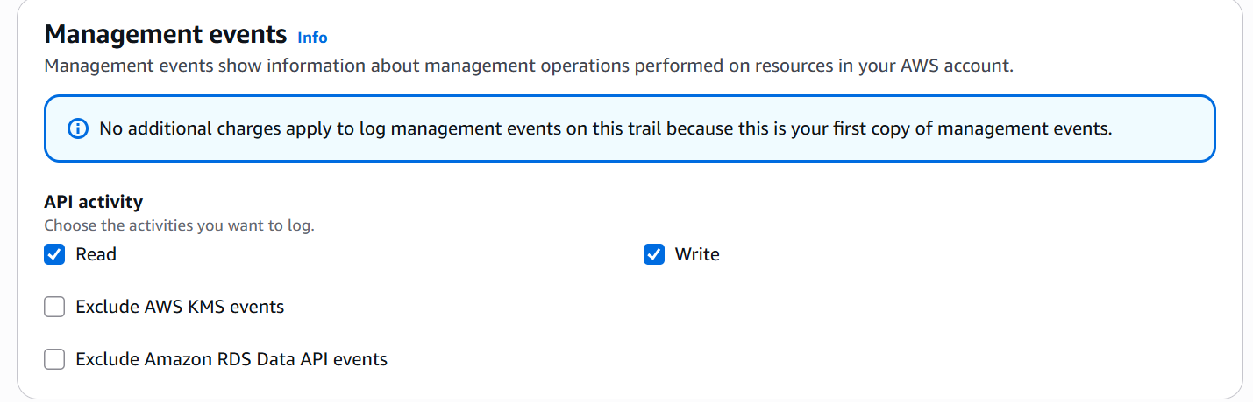

7. Click **Create trail**

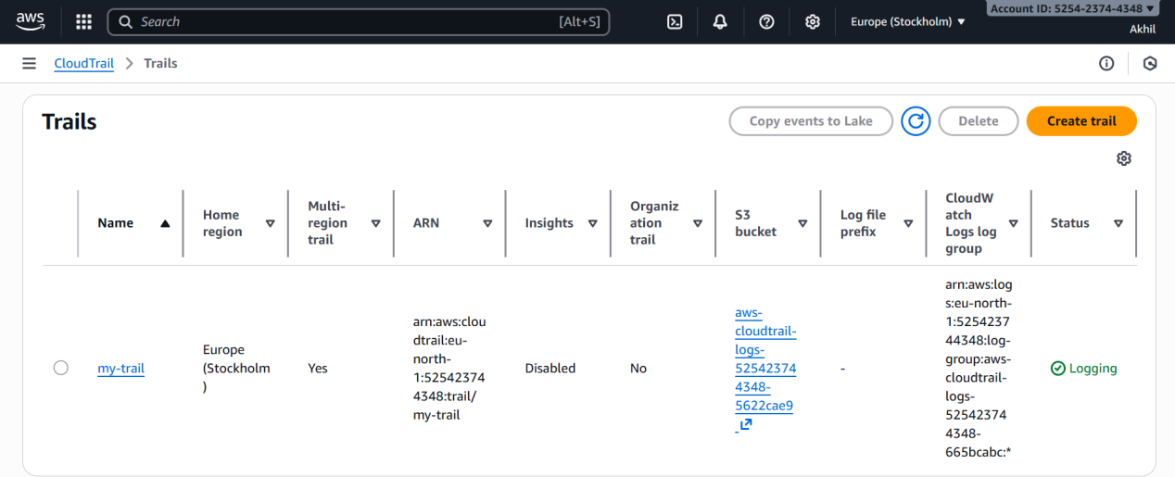

### Step 4: Verify IAM Role (Auto-created by CloudTrail)**

Ensure the role `CloudTrail_CloudWatchLogs_Role` exists with permissions to write to CloudWatch Logs.

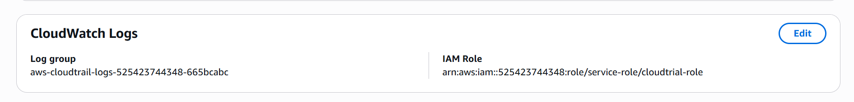

5. Validation Steps**

### **Validation in S3**

1. Go to **S3 bucket**
2. check for the logs bucket created
- Confirm that new log files (`.json.gz`) are being generated

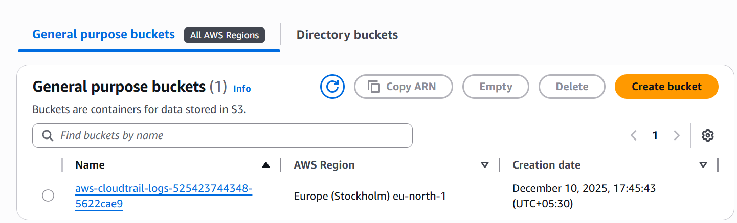
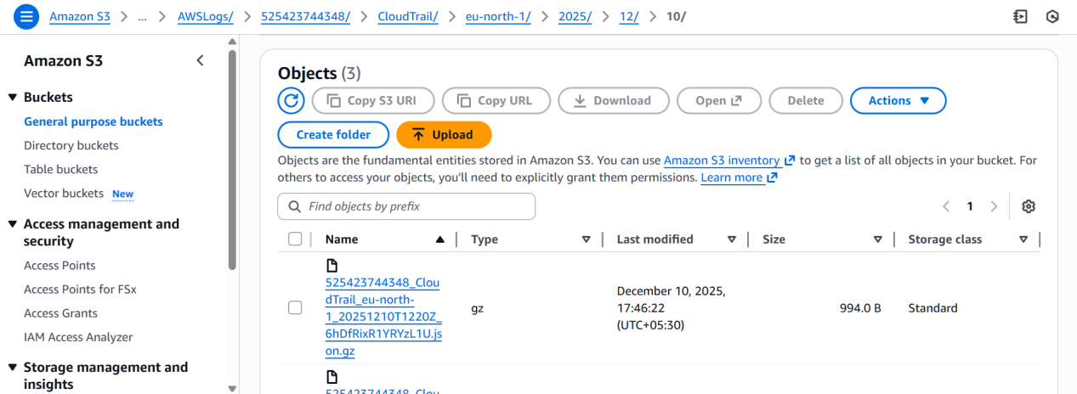

### Validation in CloudWatch Logs**

1. Go to **CloudWatch → Logs → Log Groups**
2. Open `/aws/cloudtrail/logs`
3. Verify that events are getting logged continuously

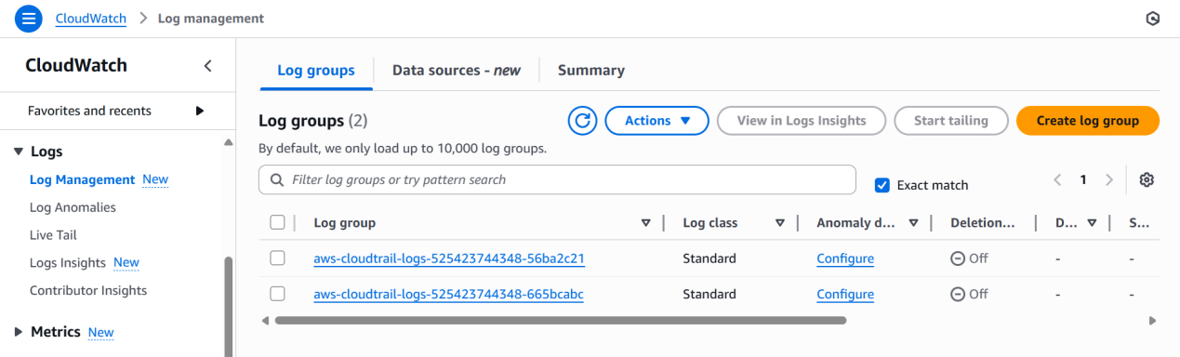

6. Conclusion**

CloudTrail monitoring has been successfully enabled, with events securely stored in S3 and streamed to CloudWatch Logs for monitoring and auditing.

- Enable SNS for cloudtrial to send alert on email.

1. Task Title**

Enable SNS Notifications for CloudTrail to Send Email Alerts

2. Objective**

To configure Amazon SNS to send email alerts whenever CloudTrail detects specific events or log entries, improving monitoring and incident response.

3. Prerequisites**

* An AWS account with IAM permissions for SNS, CloudWatch, and CloudTrail
* A working CloudTrail trail already enabled
* An email address for receiving alerts
* CloudWatch Logs integration enabled for CloudTrail (required for metric filters)

4. Step-by-Step Implementation**

### **Step 1: Create an SNS Topic**

1. Go to **Amazon SNS Console** → **Topics** → **Create topic**
2. Select **Standard**
3. Give a name (e.g., `CloudTrail-Alerts`)
4. Click **Create topic**

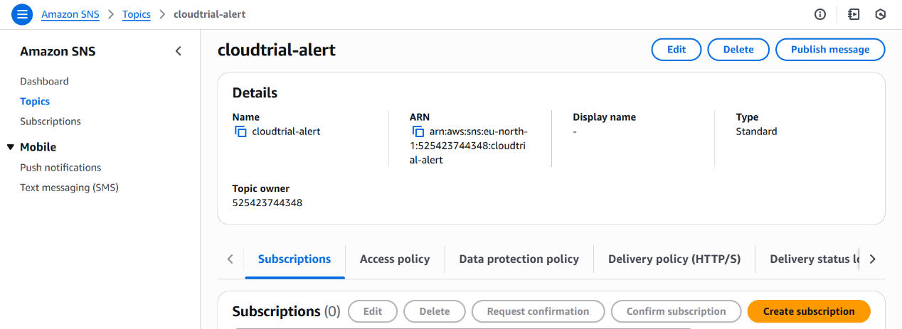
### **Step 2: Subscribe Email to SNS Topic**

1. Open the SNS topic created
2. Click **Create subscription**
3. **Protocol:** Email
4. **Endpoint:** Enter your email address
5. Check your email inbox and **confirm** the subscription

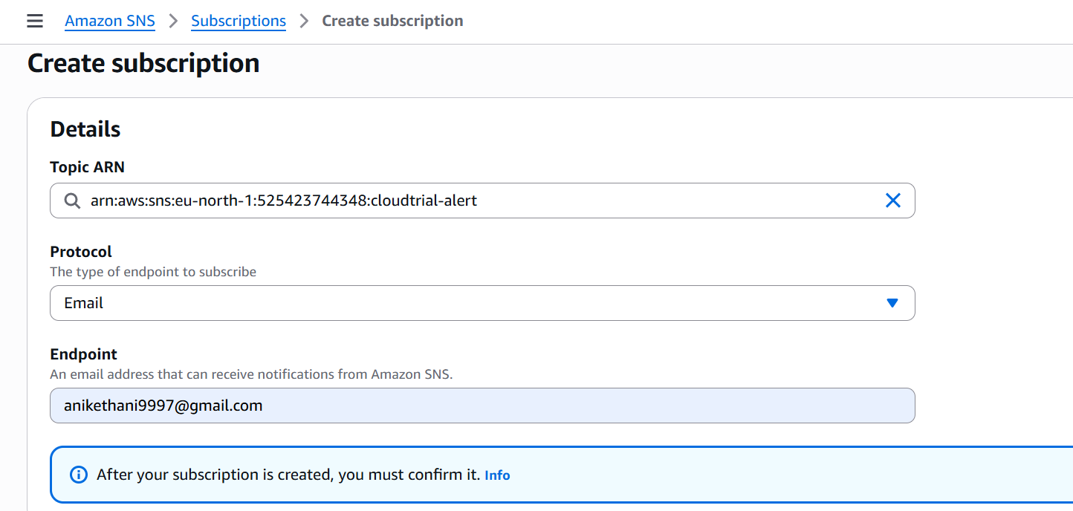

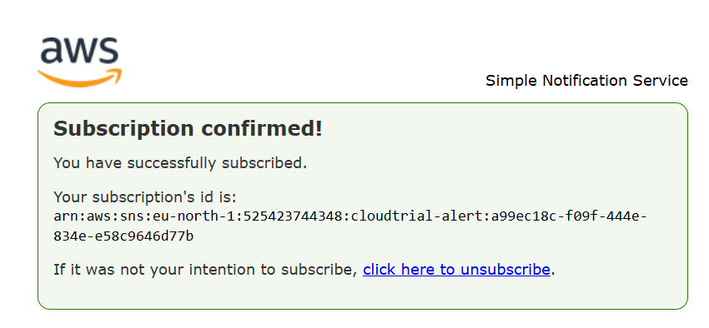

5. Validation Steps**

### **Test Email Subscription**

1. Confirm the SNS subscription email
2. SNS topic status should show **Confirmed**

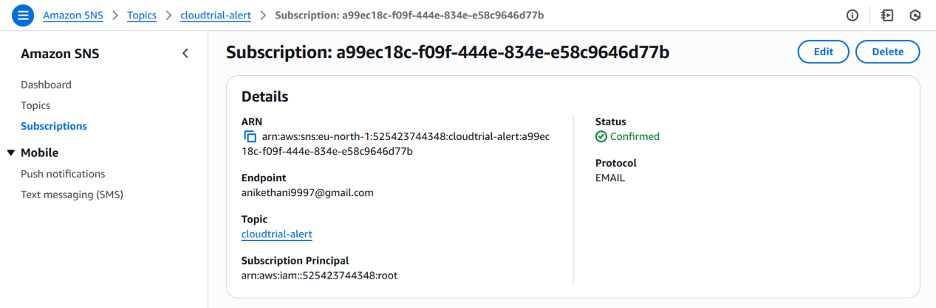

6. Conclusion**

SNS notifications for CloudTrail were successfully configured, enabling automated email alerts whenever critical events are detected.

- Configure cloud watch monitoring and record the cpu utilization and other metrics of ec2.

1. Task Title**

Configure CloudWatch Monitoring for EC2 CPU Utilization and Other Metrics

2. Objective**

To enable detailed monitoring of EC2 instances by recording CPU utilization, memory, disk, and other performance metrics using Amazon CloudWatch.
3. Prerequisites**

* AWS account with permissions for EC2 and CloudWatch
* Running EC2 instance(s)
* IAM role attached to EC2 with permission:

* `CloudWatchAgentServerPolicy`
* CloudWatch Agent installed (required for memory/disk metrics)
* SSH or SSM access to the EC2 instance

4. Step-by-Step Implementation**

### **Step 1: Enable Basic Monitoring (Default)**

AWS automatically enables basic EC2 metrics every 5 minutes:

* CPUUtilization
* NetworkIn / NetworkOut
* DiskReadBytes / DiskWriteBytes

No action required for basic metrics.

### **Step 2: Enable Detailed Monitoring (1-minute interval)**

1. Go to **EC2 Console** → **Instances**
2. Select the instance
3. Click **Actions → Monitor and troubleshoot → Manage detailed monitoring**
4. Enable **Detailed monitoring**
5. Save changes

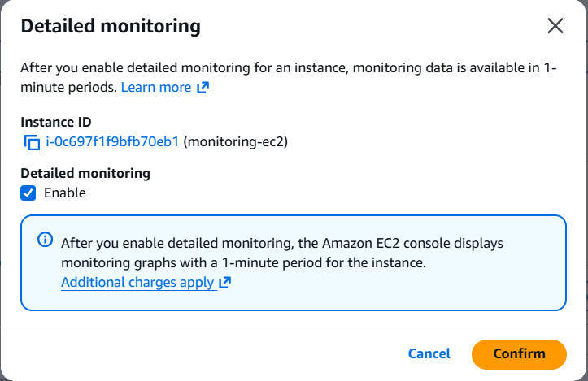

### **Step 3: Attach IAM Role for CloudWatch Agent**

1. Create IAM role (if not already created):

* Go to **IAM → Roles → Create Role**
* Select **EC2**
* Attach policy: **CloudWatchAgentServerPolicy**
2. Attach this role to your EC2 instance

### **Step 4: Install CloudWatch Agent (for Memory, Disk, etc.)**

sudo yum install amazon-cloudwatch-agent -y

### **Step 5: Create CloudWatch Agent Configuration File**

1. Run the CloudWatch Agent wizard:

sudo /opt/aws/amazon-cloudwatch-agent/bin/amazon-cloudwatch-agent-config-wizard

2. Choose metrics to collect:

* CPU
* Memory
* Disk (usage & I/O)
* Processes

3. Save config at:
`/opt/aws/amazon-cloudwatch-agent/bin/config.json`

### **Step 6: Start CloudWatch Agent**

```bash
sudo systemctl start amazon-cloudwatch-agent
sudo systemctl enable amazon-cloudwatch-agent

### **Step 7: Verify Metrics in CloudWatch**

1. Open **CloudWatch Console**
2. Go to **Metrics**
3. Check under:

* **EC2** (CPU and basic metrics)

5. Validation Steps**

### **CPU Utilization Validation**

1. Go to **CloudWatch → Metrics → EC2**
2. Select **CPUUtilization**
3. Confirm values update every 1 minute (for detailed monitoring)

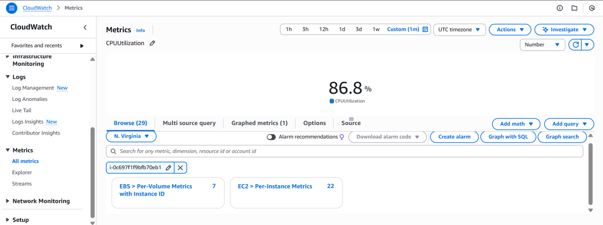
6. Conclusion**

CloudWatch monitoring was successfully configured for the EC2 instance, enabling real-time CPU utilization tracking along with additional metrics such as memory and disk usage through the CloudWatch Agent.

- Create one alarm to send alert to email if the cpu utilization is more than 70 percent.

1. Task Title**

Create CloudWatch Alarm for EC2 CPU > 70% with Email Notification

2. Objective**

Alert via email when an EC2 instance’s CPU utilization averages above 70%, enabling quick response to performance issues.

3. Prerequisites**

* AWS permissions: CloudWatch, SNS, and EC2 (e.g., `cloudwatch:PutMetricAlarm`, `sns:*`, `ec2:DescribeInstances`)
* Existing EC2 instance ID (e.g., `i-0123456789abcdef0`)
* Email address for alerts
* (Recommended) **Detailed Monitoring** enabled on the instance (1-minute metrics). Otherwise use a 5-minute period.

4. Step-by-Step Implementation**

1. **Create an SNS Topic & Email Subscription**

* Go to **Amazon SNS → Topics → Create topic** → *Standard* → Name: `CloudWatch-CPU-Alerts`.
* Open the topic → **Create subscription** → *Protocol:* Email → *Endpoint:* your email.
* **Confirm** the subscription from your inbox (status must become *Confirmed*).

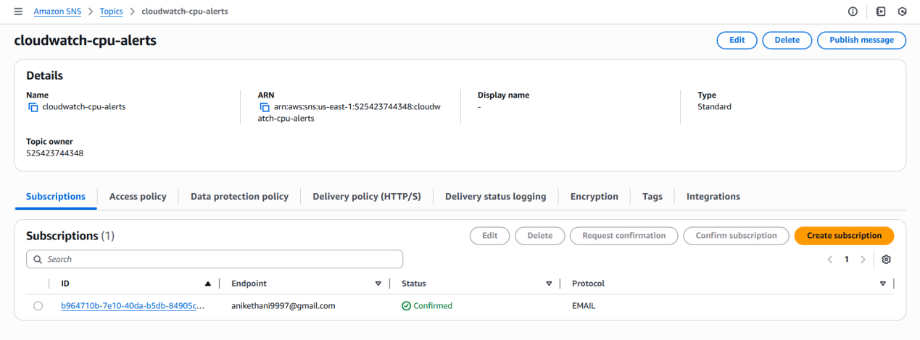

2. **Create the CloudWatch Alarm**

* Go to **CloudWatch → Alarms → Create alarm**.
* **Select metric:** *EC2 → Per-Instance Metrics → CPUUtilization* → choose your `InstanceId`.
* **Statistic:** Average
* **Period:**

* 1 minute (if Detailed Monitoring ON), otherwise 5 minutes
* **Threshold type: ** Static
* **Condition: ** Greater than `70`
* **Datapoints to alarm: ** 2 out of 2 (reduces noise)
* **Notification: ** Select the SNS topic `CloudWatch-CPU-Alerts`.
* Name: `EC2-HighCPU-70-i-0123456789abcdef0` → **Create alarm**.

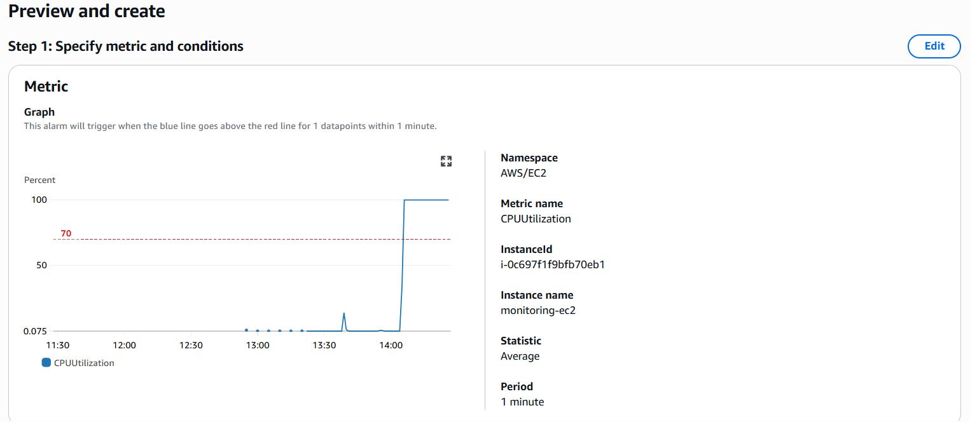

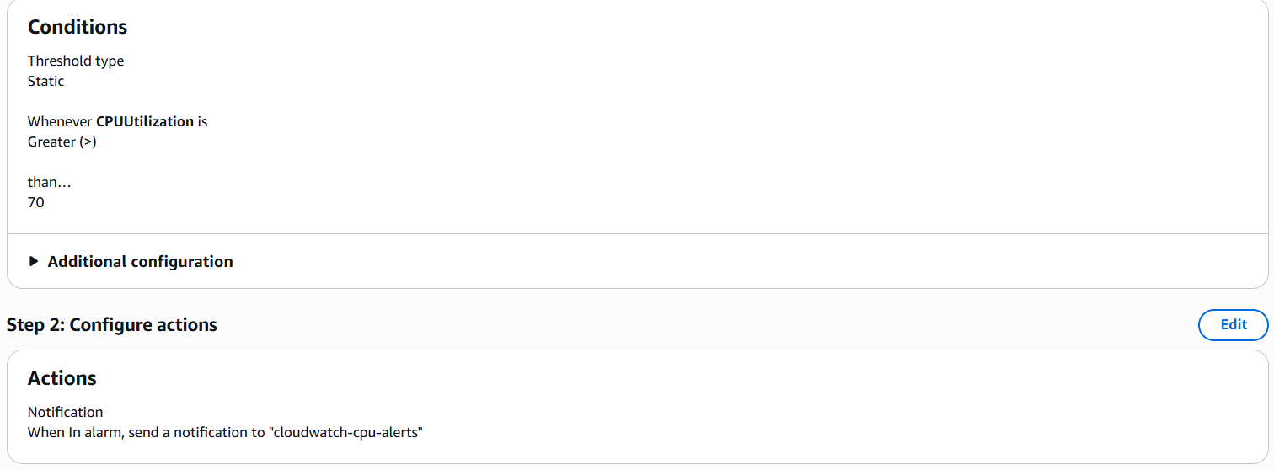
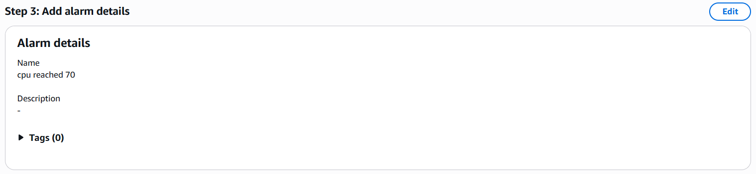

5. Validation Steps**

1. **Confirm SNS subscription** (must be *Confirmed*).
2. **Induce CPU load** on the instance (example):

```bash
sudo yum install stress -y || sudo apt-get update && sudo apt-get install stress -y
stress --cpu 4 --timeout 300
```
3. **Watch the alarm state**: CloudWatch → **Alarms** → should move **OK → ALARM** when the average exceeds 70% for the set evaluation period.
4. **Check email**: You should receive an alert from the SNS topic.
5. **Recovery**: When CPU drops, alarm returns to **OK** (you can optionally set OK notifications to the same SNS topic).

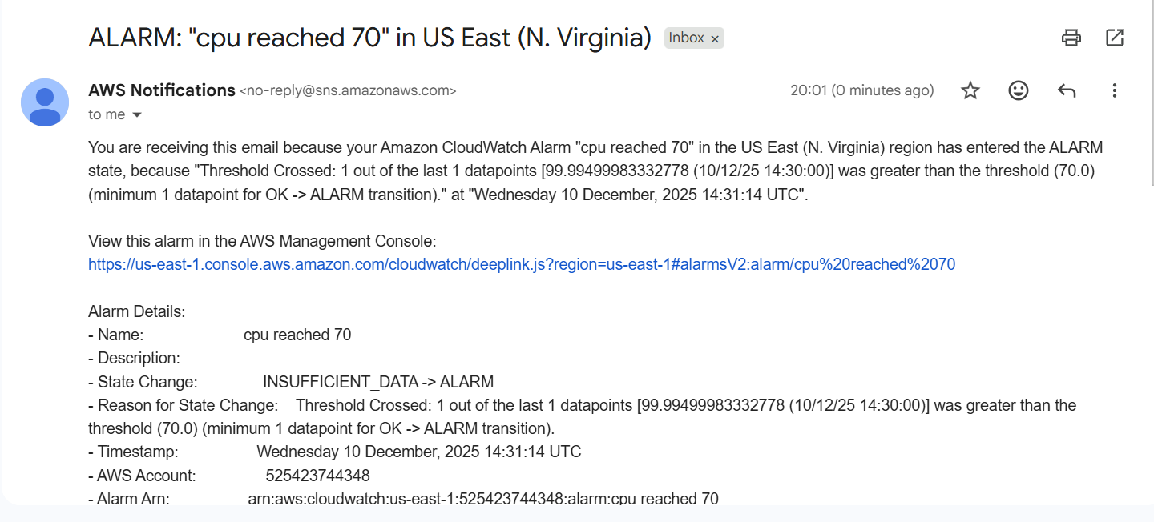
6. Conclusion**

A CloudWatch alarm has been created to email-alert when EC2 CPU utilization exceeds 70%. This ensures timely notification of performance spikes so you can investigate and remediate quickly.

- Create Dashboard and monitor tomcat service wether it is running or not and send the alert.

1. Task Title**

Create Dashboard & Alert for Tomcat Service on (EC2)

2. Objective**

Monitor whether the Tomcat service is running on an EC2 instance, visualize its status on a CloudWatch dashboard, and send an email alert if Tomcat stops.

3. Prerequisites**

* EC2 instance running Tomcat.
* IAM role attached to the instance with **`CloudWatchAgentServerPolicy`**.
* **CloudWatch Agent** installed on the instance.
* An **SNS topic + confirmed email subscription** for alerts (you can reuse the one created earlier).
* Instance has outbound internet or VPC endpoints for CloudWatch/SNS.

4. Step-by-Step Implementation**

###** A) Create the Alarm (Tomcat down → email)**

**Console path (recommended to avoid dimension typos):**

1. Go to **CloudWatch → Metrics → CWAgent**.
2. Find the `procstat_pid_count` metric (filtered by your **InstanceId**).
3. **Select metric → Create alarm**

* **Statistic:** Average
* **Period:** 1 minute (or 5 if you prefer)
* **Threshold type:** Static
* **Condition:** **Lower** than `1`
* **Evaluation periods:** 2 of 2 (reduces noise)
* **Treat missing data:** `breaching` (ensures visibility if data stops)
* **Notification:** choose your **SNS topic** (email).
* Name: `EC2-Tomcat-Down-Alarm-<InstanceId>` → **Create alarm**.

---

### **B) Create a CloudWatch Dashboard**

**Console (quick):**

1. **CloudWatch → Dashboards → Create dashboard** (e.g., `EC2-Tomcat-Monitor`).
2. Add widgets:

* **Single value** → `procstat_pid_count` (shows 1 when up, 0 when down).
* **Line** → `procstat_cpu_usage` & `procstat_memory_rss` (optional performance view).
* **Alarm status** widget → add `EC2-Tomcat-Down-Alarm-<InstanceId>`.

5. Validation Steps**

1. **Verify metrics arriving:** CloudWatch → **Metrics → CWAgent** → confirm `procstat_pid_count` > 0 while Tomcat is running.
2. **Stop Tomcat to test alert:**

```bash
sudo systemctl stop tomcat || sudo systemctl stop tomcat9 || sudo systemctl stop apache-tomcat
```

(use the one that matches your service name)
3. **Alarm behavior:** After 2 evaluation periods, the alarm should change to **ALARM** and you should receive an **email**.
4. **Recover:**

```bash
sudo systemctl start tomcat
```

Alarm returns to **OK**, `procstat_pid_count` back to ≥1.
5. **Dashboard check:** PID single-value widget shows 0 when down, 1+ when up; alarm widget reflects state.

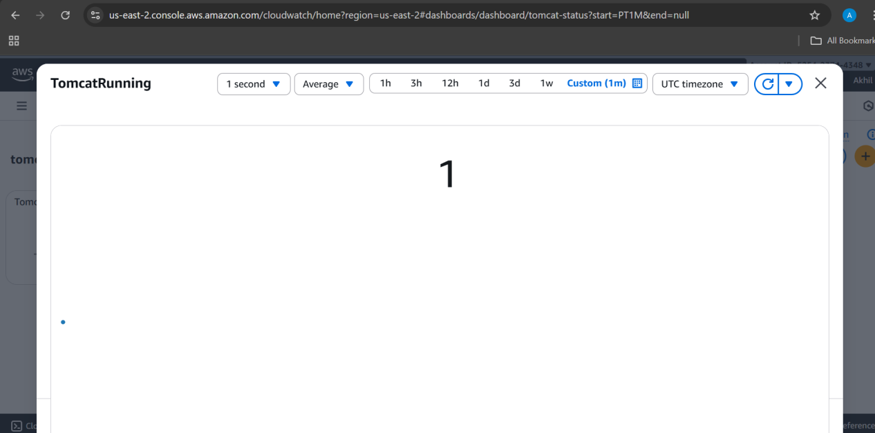

6. Conclusion**

A CloudWatch Agent **procstat** configuration now publishes Tomcat process metrics. A **dashboard** visualizes status and performance, and a **CloudWatch alarm** sends an **email alert** if Tomcat stops (PID count < 1).

- Create Dashboard and monitor nginx service to send the alert if nginx is not running.

1. Task Title**

Create CloudWatch Dashboard & Alert for Nginx Service Status (Console Only)

2. Objective**

Monitor whether the Nginx service is running on an EC2 instance by sending its status (1 = running, 0 = stopped) to CloudWatch using a script, then create a console-based dashboard and alarm to alert via email when Nginx stops.

3. Prerequisites**

* Running EC2 instance with Nginx installed
* IAM role attached to instance with permission `cloudwatch:PutMetricData`
* AWS CLI installed on the EC2 instance
* SNS Topic + confirmed email subscription
* Region identified (e.g., ap-south-1)
* Access to CloudWatch Console

4. Step-by-Step Implementation (Console + Bash Integration)**

### **A) Create Bash Script to Push Nginx Status (1/0) to CloudWatch**

> This replaces CloudWatch Agent — only simple Bash script.

On the EC2 instance, create `/usr/local/bin/nginx_status.sh`:

```bash
#!/usr/bin/env bash

set -euo pipefail

NAMESPACE="Custom/Nginx"
METRIC="NginxRunning"
REGION="ap-south-1"
PATTERN='nginx: master process'

# instance-id via IMDSv2
TOKEN=$(curl -sS -X PUT "http://169.254.169.254/latest/api/token" \
-H "X-aws-ec2-metadata-token-ttl-seconds: 21600")
IID=$(curl -sS -H "X-aws-ec2-metadata-token: ${TOKEN}" \
http://169.254.169.254/latest/meta-data/instance-id)

# Detect Nginx
if pgrep -f "${PATTERN}" >/dev/null 2>&1; then
VAL=1
else
VAL=0
fi

echo "$VAL"

aws cloudwatch put-metric-data \
--namespace "$NAMESPACE" \
--metric-name "$METRIC" \
--dimensions InstanceId="$IID" \
--value "$VAL" \
--unit Count \
--region "$REGION"
```

Make executable:

```bash
sudo chmod +x /usr/local/bin/nginx_status.sh
```

Test:

```bash
/usr/local/bin/nginx_status.sh
```

---

### **B) Schedule Script Every Minute With cron**

Edit crontab:

```bash
sudo crontab -e
```

Add:

```
* * * * * /usr/local/bin/nginx_status.sh >/dev/null 2>&1
```

This updates CloudWatch with 1/0 every minute.

---

### **C) Create CloudWatch Alarm (Console)**

1. Open **AWS Console → CloudWatch → Metrics**
2. Go to **Custom Namespaces → Custom/Nginx**
3. Choose the metric:

* **nginx running**
* Dimension: **Instance Id = your EC2 instance**
4. Click **Create alarm**
5. Configure alarm:

* **Statistic:** Average
* **Period:** 1 minute
* **Threshold:**

* *Whenever nginx running is* **< 1**
* Evaluation periods: **2 of 2**
6. Under **Notification**, choose your SNS Topic
7. Alarm name:
`EC2-Nginx-Down-Alarm`
8. Click **Create alarm**

---

### **D) Create CloudWatch Dashboard (Console)**

1. Go to **CloudWatch → Dashboards**
2. Click **Create dashboard**
3. Name it: `Nginx-Monitoring`
4. Choose **Line** or **Single Value** widget
5. Add metric:

* Namespace: **Custom/Nginx**
* Metric: **NginxRunning**
* Dimension: **InstanceId=your instance**
6. Click **Add widget**
7. Add another widget → **Add alarm status widget**

* Select alarm: `EC2-Nginx-Down-Alarm`

Dashboard should show:

* Current Nginx status (1 = running, 0 = not running)
* Alarm state (OK / ALARM)

5. Validation Steps**

1. Wait 2–3 minutes to ensure metrics appear in **CloudWatch → Metrics → Custom/Nginx**
2. Stop Nginx to test:

```bash
sudo systemctl stop nginx
```
3. Wait for two cron cycles → alarm moves to **ALARM**
4. Check your **email** → Nginx down alert
5. Start Nginx:

```bash
sudo systemctl start nginx
```
6. Alarm returns to **OK**, and dashboard shows new metric value = 1

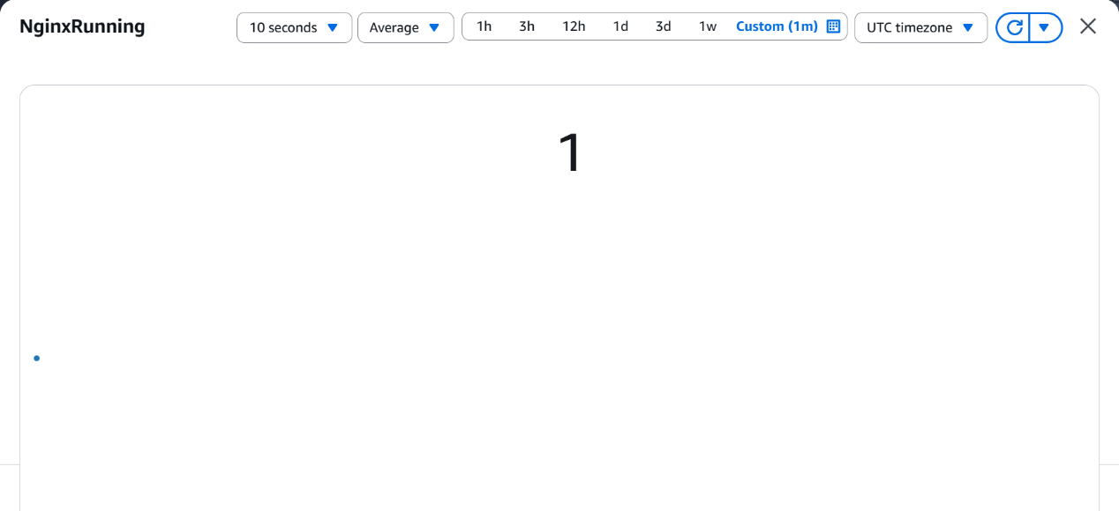

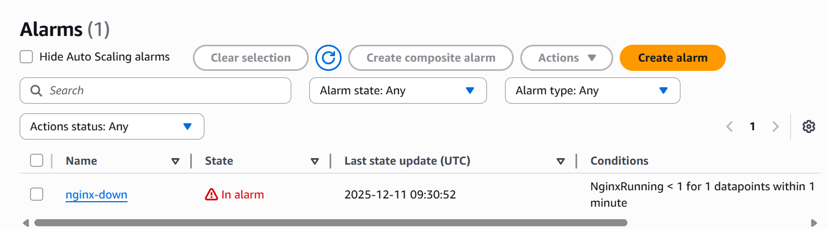

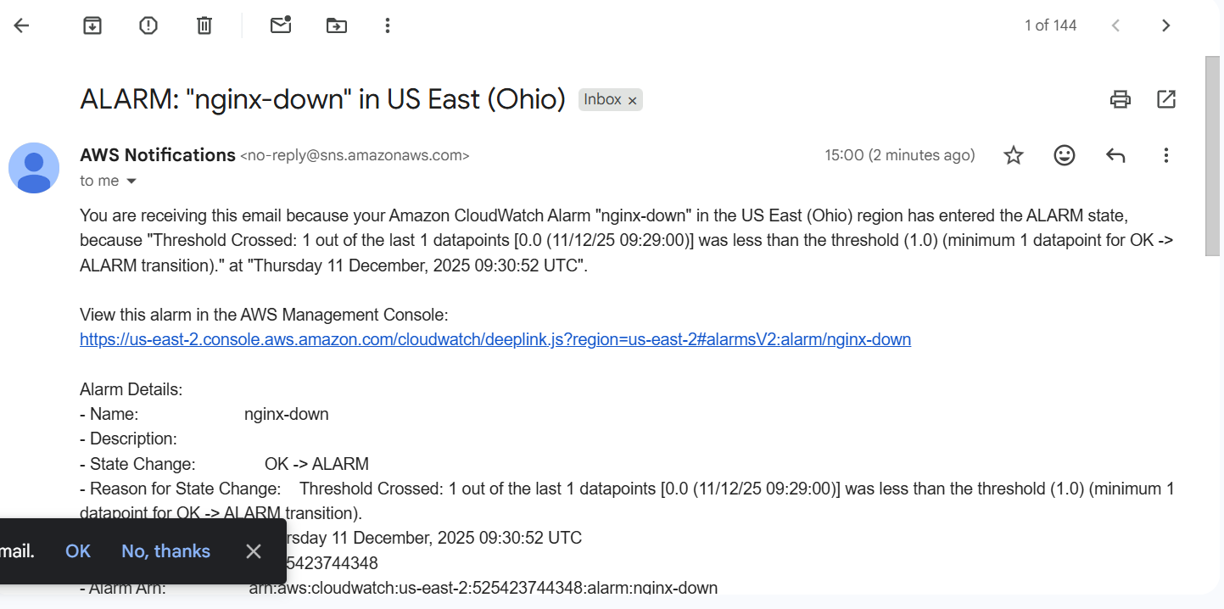

6. Conclusion**

A complete monitoring setup for Nginx has been created using a bash script to send a custom metric, a CloudWatch dashboard for visualization, and an alarm that emails you whenever Nginx stops running.

